ATLAS Platform - AI Utilization and Rule-Based Analysis

1. Executive Summary
ATLAS uses a hybrid analysis design: deterministic legal rules are the compliance backbone, while AI provides classification, report enhancement, and investigative suggestions.

2. Where AI Is Used in ATLAS
- FIR classification pipeline (section-map + model fallbacks).
- Section-versus-narrative mismatch flagging for FIR triage.
- Validation report enhancement with narrative summarization and de-duplication.
- Evidence gap hybrid analysis (deterministic expected gaps + AI-suggested pattern gaps).
- Reviewer-facing summaries and prioritization in chargesheet review UI.

3. AI Components and Their Purpose

3.1 FIR Classification
- Uses legal section-map inference first when sections are available and mappable.
- Falls back to model-driven NLP path when deterministic section mapping is insufficient.
- Returns category, confidence, and method metadata for auditing and review.
- Can trigger review_needed status when NLP and section inference disagree.

3.2 Legal NLP Enhancement
- Improves readability of deterministic findings using summary text generation.
- Suppresses near-duplicate recommendations and marks likely routine findings.
- Keeps deterministic legal findings intact; does not override rule outcomes.

3.3 Evidence Hybrid Layer
- Tier 1: deterministic expected-evidence logic from taxonomy and charge context.
- Tier 2: AI/ML pattern suggestions to identify likely missing evidence beyond strict subtraction.
- Produces merged evidence gaps, present evidence, coverage percentage, totals, and summary.

4. Rules in Chargesheet Analysis
Chargesheet legal validation executes seven deterministic rules in sequence. Rules 1 and 2 are cross-document and require linked FIR context; Rules 3 to 7 are internal consistency checks and always run.
Rule | What it checks | When it runs
RULE_1 | Sections in chargesheet but not in FIR | Only with linked FIR
RULE_2 | Sections in FIR missing from chargesheet | Only with linked FIR
RULE_3 | Invalid/mutually exclusive combinations | Always
RULE_4 | Missing companion sections | Always
RULE_5 | Procedural and legal requirement gaps | Always
RULE_6 | IPC/BNS consistency with date/act | Always
RULE_7 | Evidence sufficiency against mandatory expectations | Always

5. Chargesheet Analysis Flow
- Upload and authorize chargesheet input.
- Extract and parse structured fields (charges, evidence, witnesses, metadata).
- Attempt FIR linkage by FIR reference number.
- Run deterministic RULE_1 to RULE_7 validation pipeline.
- Enhance findings for reviewer readability using legal NLP layer.
- Run hybrid evidence-gap pipeline (deterministic plus AI suggestions).
- Persist reports and present them in reviewer workflow endpoints/UI.
- Track reviewer decisions through audit-chain endpoints.

6. Diagrams

6.1 AI Placement and Decision Flow
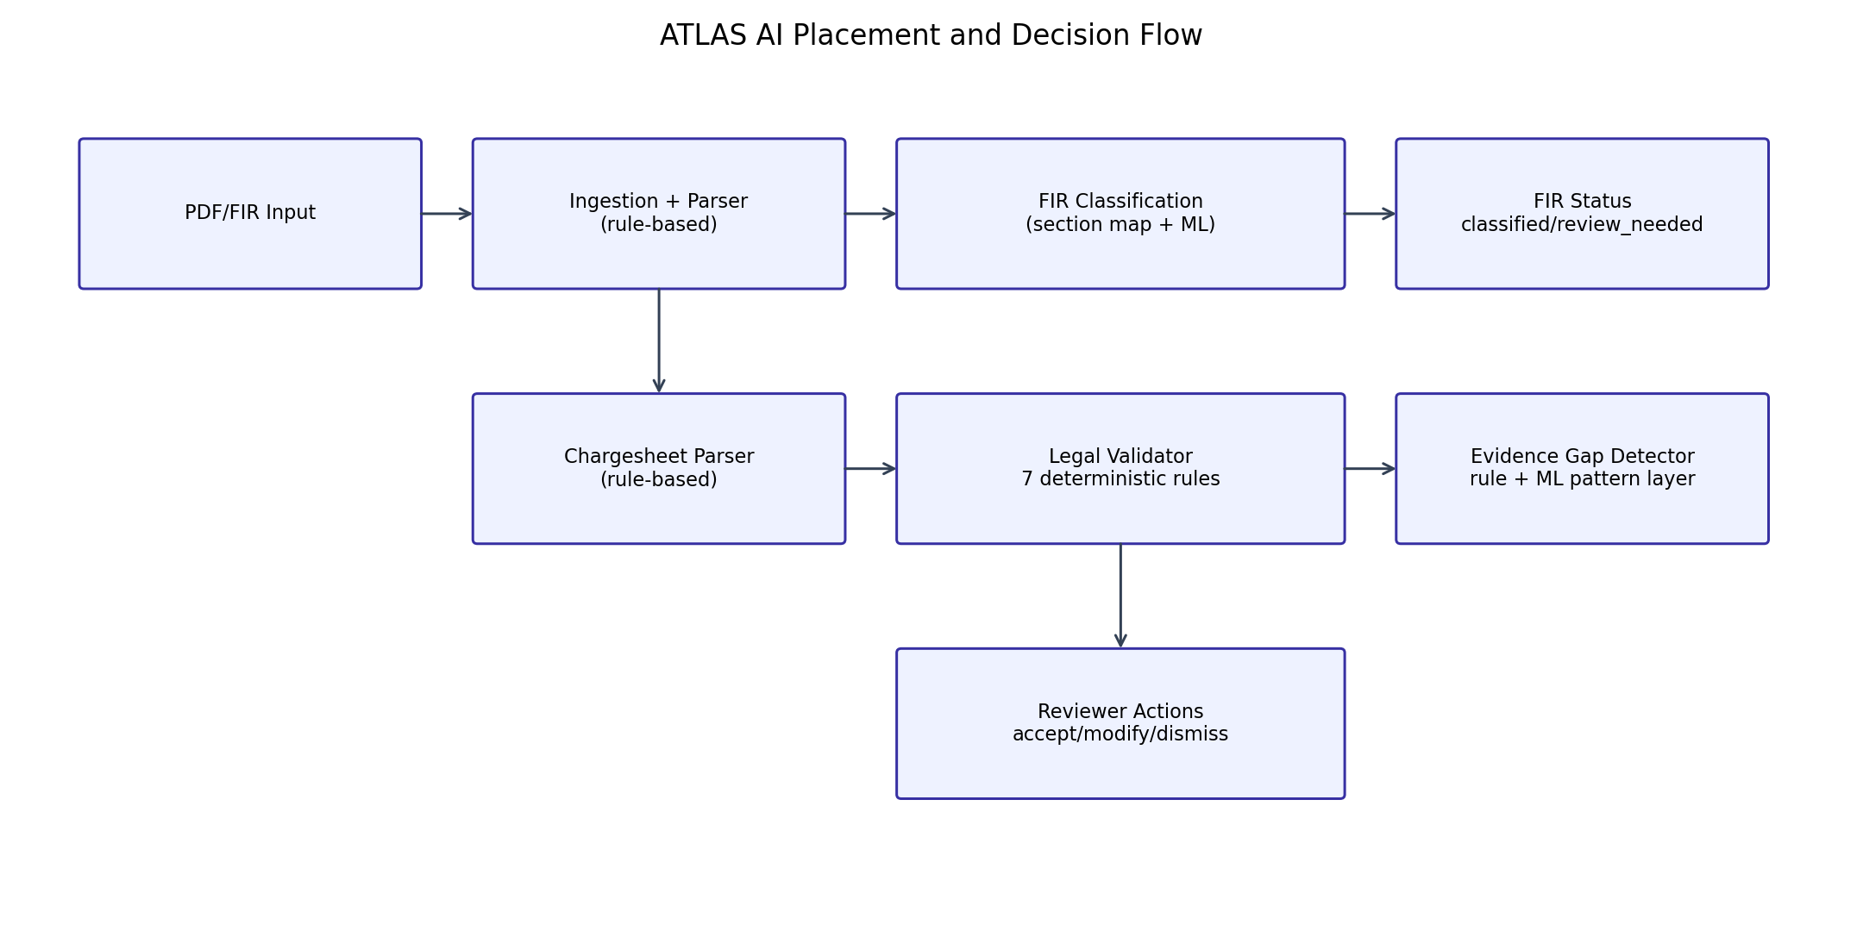
Figure 1. System-level view of where AI and deterministic logic are applied.

6.2 Rule Execution in Chargesheet Validation
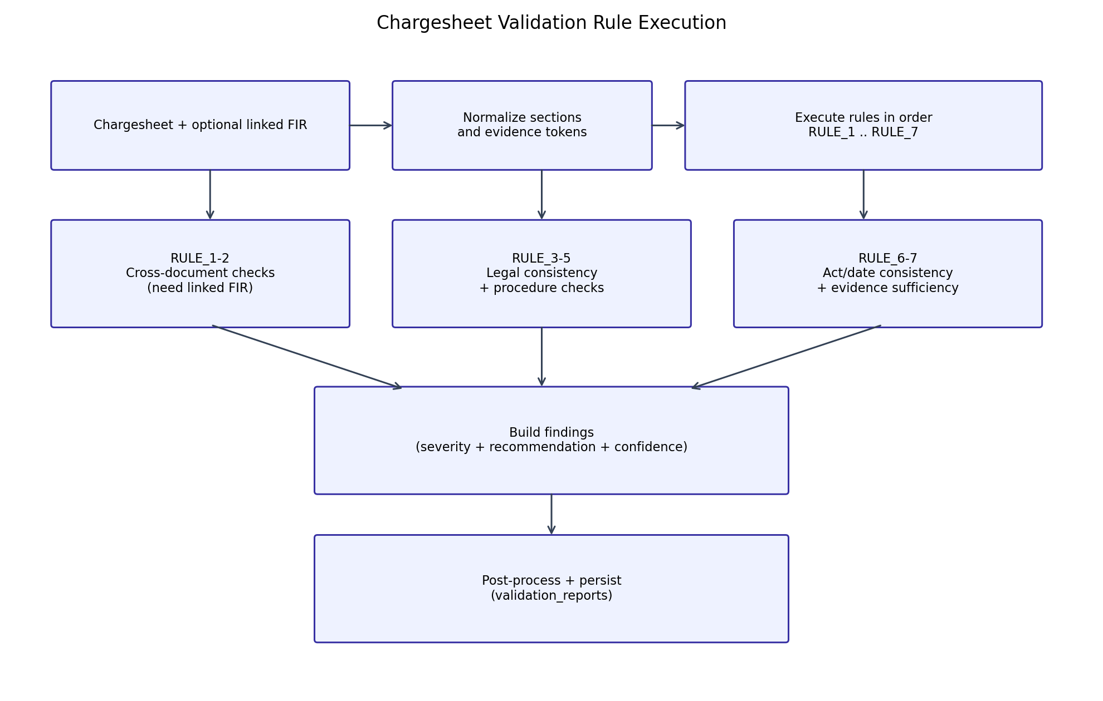
Figure 2. Deterministic rule sequencing, finding construction, and persistence.

6.3 Hybrid Evidence Gap Analysis
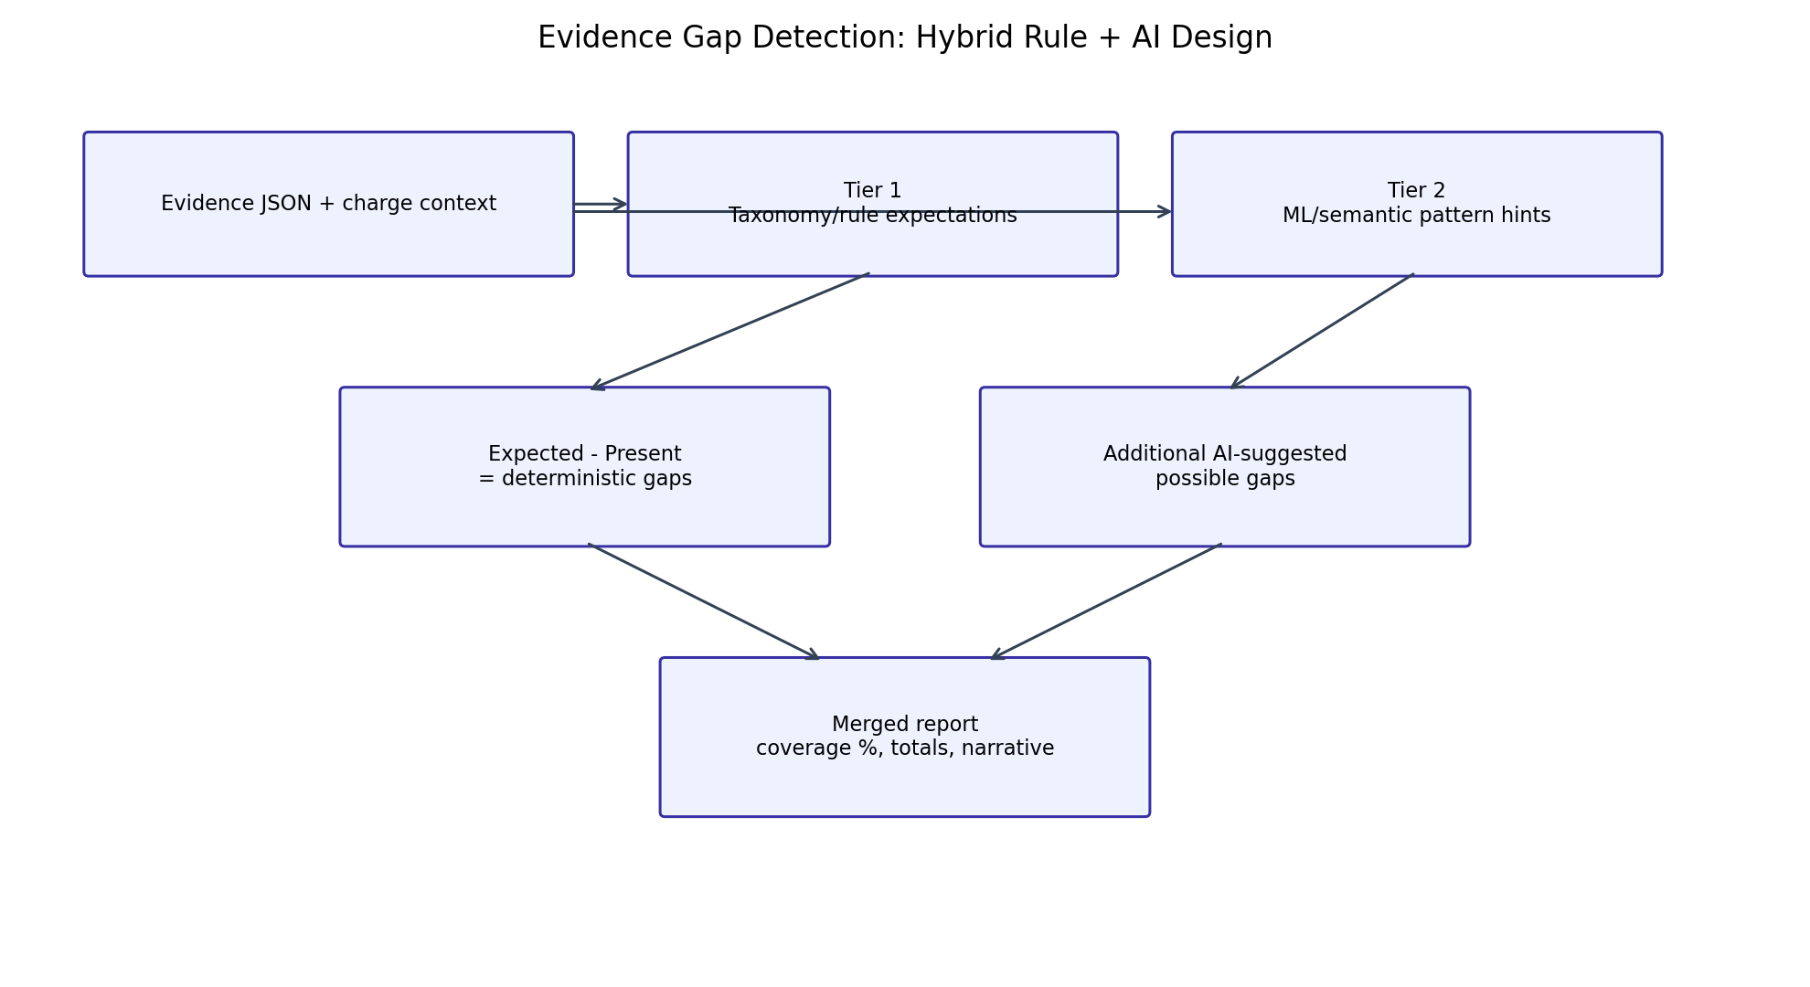
Figure 3. Tiered evidence gap generation with deterministic and AI components.

7. Control and Governance Notes
- Deterministic legal rules remain the source of compliance-critical outcomes.
- AI is assistive and advisory; reviewer actions are final and auditable.
- Role and district scoping controls still govern data visibility and actions.
- Schema migrations are required for complete chargesheet analysis operation.

